Computer Programming I — Homework Assignment #11

**Problem:** Design a UNI Air Domestic Flights Booking System

**Functions:**

1. Booking (訂票): Insert a new record into the binary file **Reservations.dat**. Any passenger cannot book twice the same flight on the same day.
2. Booking inquiry (訂票紀錄查詢): Input an ID number, then display the reservation information of the passenger.
3. Refund application (刪除訂票資料): Delete a record from the binary file **Reservations.dat**.

**Requirements:**

1. Global variables, except **airportName** , **fullFare** , **discount** and **maxNumReservations**, are not allowed.

**Remark:** The **flightNo** is unique in each flight.

The file record format of the file **Reservations.dat**:

**char flightNo[ 8 ]; // Flight number**

**char id[ 12 ]; // ID number**

**char name[ 8 ]; // Name**

**char mobile[ 12 ]; // Mobile phone number**

**char date[ 12 ]; // Departure date**

**int tickets[ 8 ];**

**// tickets[ 0 ]: not used**

**// tickets[ 1 ]: number of full fare tickets**

**// tickets[ 2 ]: number of child tickets**

**// tickets[ 3 ]: number of infant tickets**

**// tickets[ 4 ]: number of senior citizen tickets**

**// tickets[ 5 ]: number of impaired tickets**

**// tickets[ 6 ]: number of impaired companion tickets**

**// tickets[ 7 ]: number of military tickets**

The file record format of the file **Flight Schedule.dat**:

**char flightNo[ 8 ]; // Flight number**

**int departureAirport; // Departure airport code**

**int arrivalAirport; // Arrival airport code**

**char departureTime[ 8 ]; // Departure time**

**char arrivalTime[ 8 ]; // Arrival time**

The screen dialog should appear as follows:

|  |
| --- |
| Welcome to UNI Air Domestic Flights Booking System  Input your choice:  1. Booking  2. Booking enquiry  3. Refund application  4. End  ? 2  Enter ID number: 999  No reservations! displayed in bookingInquiry  Input your choice:  1. Booking  2. Booking enquiry  3. Refund application  4. End  ? 3  Enter ID number: 999  No reservations! displayed in bookingInquiry  Input your choice:  1. Booking  2. Booking enquiry  3. Refund application  4. End  ? 1  Departure airport: displayed in booking  1. Taipei  2. Taichung  3. Chiayi  4. Tainan  5. Kaohsiung  6. Hualien  7. Taitung  8. Penghu  9. Kinmen  10. Beigan  11. Nangan  ? 0  Departure airport:  1. Taipei  2. Taichung  3. Chiayi  4. Tainan  5. Kaohsiung  6. Hualien  7. Taitung  8. Penghu  9. Kinmen  10. Beigan  11. Nangan  ? 12  Departure airport:  1. Taipei  2. Taichung  3. Chiayi  4. Tainan  5. Kaohsiung  6. Hualien  7. Taitung  8. Penghu  9. Kinmen  10. Beigan  11. Nangan  ? 2  Arrival airport: displayed in chooseArrivalAirport  8. Penghu  9. Kinmen  11. Nangan  ? 7  Arrival airport:  8. Penghu  9. Kinmen  11. Nangan  ? 10  Arrival airport:  8. Penghu  9. Kinmen  11. Nangan  ? 12  Arrival airport:  8. Penghu  9. Kinmen  11. Nangan  ? 8  Departure date (yyyy/mm/dd): 2022/12/12 displayed in booking  Taichung to Penghu / Depart date: 2022/12/12.  Flight Departure Arrival Fare  8631 08:30 09:15 1769  8635 11:30 12:15 1769  8639 15:10 15:55 1769  8651 18:00 18:45 1769  Flight number: 8632 displayed in chooseFlight  Flight number: 8631  Number of infant tickets (0 ~ 4): 4  Number of full fare tickets (0 ~ 4): 2  Number of child tickets (0 ~ 4): 5  Number of senior citizen tickets (0 ~ 4): 0  Number of impaired tickets (0 ~ 4): 0  Number of impaired companion tickets (0 ~ 4): 0  Number of military tickets (0 ~ 4): 0  This booking system accepts a maximum of 4 passengers( including children ) per booking.  If there are more than 4 passengers, please make multiple bookings.  Number of full fare tickets (0 ~ 4): 2  Number of child tickets (0 ~ 4): 2  Number of senior citizen tickets (0 ~ 4): 0  Number of impaired tickets (0 ~ 4): 0  Number of impaired companion tickets (0 ~ 4): 0  Number of military tickets (0 ~ 4): 0  Each infant must always be accompanied by at least one adult.  Number of full fare tickets (0 ~ 4): 0  Number of child tickets (0 ~ 4): 0  Number of senior citizen tickets (0 ~ 4): 1  Number of impaired tickets (0 ~ 4): 1  Number of impaired companion tickets (0 ~ 4): 1  Number of military tickets (0 ~ 4): 1  Ticket information: displayed in displayReservations  Date: 2022/12/12  Flight: B7-8631  Taichung -> Penghu  08:30 09:15  Infant Fare TWD 0 x 4  Senior Citizen Fare TWD 884 x 1  Impaired Fare TWD 884 x 1  Impaired Companion Fare TWD 884 x 1  Military Fare TWD 1680 x 1  Total: 4332  ID number: 999  Name: 999  Mobile: 999  Booking completed!  Input your choice:  1. Booking  2. Booking enquiry  3. Refund application  4. End  ? 2  Enter ID number: 999  displayed in bookingInquiry  1. Ticket information: displayed in displayReservations  Date: 2022/12/12  Flight: B7-8631  Taichung -> Penghu  08:30 09:15  Infant Fare TWD 0 x 4  Senior Citizen Fare TWD 884 x 1  Impaired Fare TWD 884 x 1  Impaired Companion Fare TWD 884 x 1  Military Fare TWD 1680 x 1  Total: 4332  Input your choice:  1. Booking  2. Booking enquiry  3. Refund application  4. End  ? 2  Enter ID number: 888  No reservations! displayed in bookingInquiry  Input your choice:  1. Booking  2. Booking enquiry  3. Refund application  4. End  ? 1  Departure airport: displayed in booking  1. Taipei  2. Taichung  3. Chiayi  4. Tainan  5. Kaohsiung  6. Hualien  7. Taitung  8. Penghu  9. Kinmen  10. Beigan  11. Nangan  ? 8  Arrival airport: displayed in chooseArrivalAirport  1. Taipei  2. Taichung  3. Chiayi  4. Tainan  5. Kaohsiung  9. Kinmen  ? 6  Arrival airport:  1. Taipei  2. Taichung  3. Chiayi  4. Tainan  5. Kaohsiung  9. Kinmen  ? 2  Departure date (yyyy/mm/dd): 2022/12/13  Penghu to Taichung / Depart date: 2022/12/13.  Flight Departure Arrival Fare  8632 10:00 10:40 1769  8636 13:00 13:40 1769  8640 16:30 17:10 1769  8652 19:20 20:00 1769  Flight number: 8640  Number of infant tickets (0 ~ 4): 1  Number of full fare tickets (0 ~ 4): 1  Number of child tickets (0 ~ 4): 2  Number of senior citizen tickets (0 ~ 4): 1  Number of impaired tickets (0 ~ 4): 0  Number of impaired companion tickets (0 ~ 4): 0  Number of military tickets (0 ~ 4): 0  Ticket information:  Date: 2022/12/13  Flight: B7-8640  Penghu -> Taichung  16:30 17:10  Full Fare TWD 1769 x 1  Child Fare TWD 1326 x 2  Infant Fare TWD 0 x 1  Senior Citizen Fare TWD 884 x 1  Total: 5305  ID number: 999  Name: 999  Mobile: 999  Booking completed!  Input your choice:  1. Booking  2. Booking enquiry  3. Refund application  4. End  ? 2  Enter ID number: 999  displayed in bookingInquiry  1. Ticket information: displayed in displayReservations  Date: 2022/12/12  Flight: B7-8631  Taichung -> Penghu  08:30 09:15  Infant Fare TWD 0 x 4  Senior Citizen Fare TWD 884 x 1  Impaired Fare TWD 884 x 1  Impaired Companion Fare TWD 884 x 1  Military Fare TWD 1680 x 1  Total: 4332  displayed in bookingInquiry  2. Ticket information: displayed in displayReservations  Date: 2022/12/13  Flight: B7-8640  Penghu -> Taichung  16:30 17:10  Full Fare TWD 1769 x 1  Child Fare TWD 1326 x 2  Infant Fare TWD 0 x 1  Senior Citizen Fare TWD 884 x 1  Total: 5305  Input your choice:  1. Booking  2. Booking enquiry  3. Refund application  4. End  ? 3  Enter ID number: 888 displayed in refundApplication  No reservations! displayed in bookingInquiry  Input your choice:  1. Booking  2. Booking enquiry  3. Refund application  4. End  ? 3  Enter ID number: 999  1. Ticket information:  Date: 2022/12/12  Flight: B7-8631  Taichung -> Penghu  08:30 09:15  Infant Fare TWD 0 x 4  Senior Citizen Fare TWD 884 x 1  Impaired Fare TWD 884 x 1  Impaired Companion Fare TWD 884 x 1  Military Fare TWD 1680 x 1  Total: 4332  2. Ticket information:  Date: 2022/12/13  Flight: B7-8640  Penghu -> Taichung  16:30 17:10  Full Fare TWD 1769 x 1  Child Fare TWD 1326 x 2  Infant Fare TWD 0 x 1  Senior Citizen Fare TWD 884 x 1  Total: 5305  Enter your choice: 1 displayed in refundApplication  The seleted booking has been deleted.  Input your choice:  1. Booking  2. Booking enquiry  3. Refund application  4. End  ? 2  Enter ID number: 999  1. Ticket information:  Date: 2022/12/13  Flight: B7-8640  Penghu -> Taichung  16:30 17:10  Full Fare TWD 1769 x 1  Child Fare TWD 1326 x 2  Infant Fare TWD 0 x 1  Senior Citizen Fare TWD 884 x 1  Total: 5305  Input your choice:  1. Booking  2. Booking enquiry  3. Refund application  4. End  ? 4  請按任意鍵繼續 . . . |

|  |
| --- |
| Welcome to UNI Air Domestic Flights Booking System  Input your choice:  1. Booking  2. Booking enquiry  3. Refund application  4. End  ? 2  Enter ID number: 999  1. Ticket information:  Date: 2022/12/13  Flight: B7-8640  Penghu -> Taichung  16:30 17:10  Full Fare TWD 1769 x 1  Child Fare TWD 1326 x 2  Infant Fare TWD 0 x 1  Senior Citizen Fare TWD 884 x 1  Total: 5305  Input your choice:  1. Booking  2. Booking enquiry  3. Refund application  4. End  ? 1  Departure airport:  1. Taipei  2. Taichung  3. Chiayi  4. Tainan  5. Kaohsiung  6. Hualien  7. Taitung  8. Penghu  9. Kinmen  10. Beigan  11. Nangan  ? 8  Arrival airport:  1. Taipei  2. Taichung  3. Chiayi  4. Tainan  5. Kaohsiung  9. Kinmen  ? 2  Departure date (yyyy/mm/dd): 2022/12/13  Penghu to Taichung / Depart date: 2022/12/13.  Flight Departure Arrival Fare  8632 10:00 10:40 1769  8636 13:00 13:40 1769  8640 16:30 17:10 1769  8652 19:20 20:00 1769  Flight number: 8640  Number of infant tickets (0 ~ 4): 0  Number of full fare tickets (0 ~ 4): 1  Number of child tickets (0 ~ 4): 0  Number of senior citizen tickets (0 ~ 4): 0  Number of impaired tickets (0 ~ 4): 0  Number of impaired companion tickets (0 ~ 4): 0  Number of military tickets (0 ~ 4): 0  Ticket information:  Date: 2022/12/13  Flight: B7-8640  Penghu -> Taichung  16:30 17:10  Full Fare TWD 1769 x 1  Total: 1769  ID number: 999  displayed in duplicate  The reservation appears to be a duplicate to an existing reservation!  Input your choice:  1. Booking  2. Booking enquiry  3. Refund application  4. End  ? 4  請按任意鍵繼續 . . . |

Call Graph

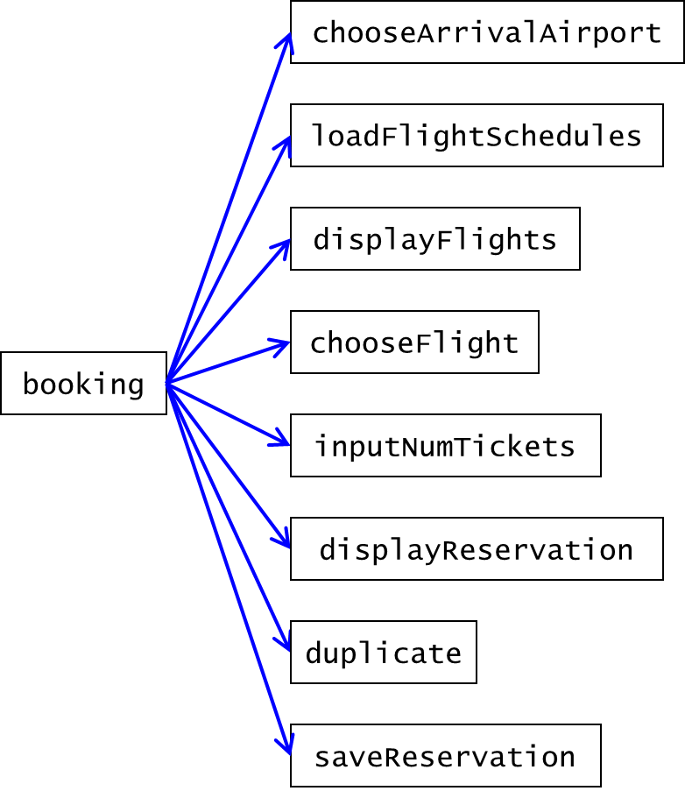

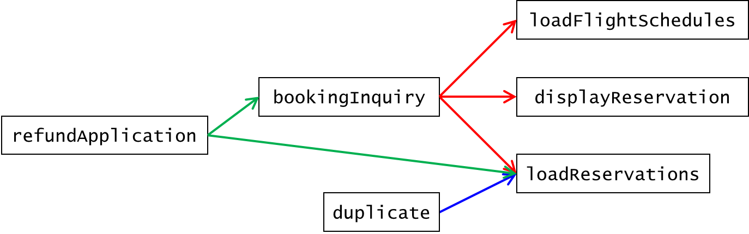

Airport code

|  |  |  |
| --- | --- | --- |
| Code | Airport | 機場 |
| 1 | Taipei | 臺北 |
| 2 | Taichung | 臺中 |
| 3 | Chiayi | 嘉義 |
| 4 | Tainan | 臺南 |
| 5 | Kaohsiung | 高雄 |
| 6 | Hualien | 花蓮 |
| 7 | Taitung | 臺東 |
| 8 | Penghu | 澎湖 |
| 9 | Kinmen | 金門 |
| 10 | Beigan | 北竿 |
| 11 | Nangan | 南竿 |

Full Fare

|  |  |  |  |  |  |  |  |  |  |  |  |
| --- | --- | --- | --- | --- | --- | --- | --- | --- | --- | --- | --- |
|  | Taip | Taic | Chia | Tain | Kaoh | Hual | Tait | Peng | Kinm | Beig | Nang |
| Taipei | 0 | 0 | 0 | 0 | 0 | 1781 | 2460 | 2296 | 2618 | 2197 | 2197 |
| Taichung | 0 | 0 | 0 | 0 | 0 | 0 | 0 | 1769 | 2236 | 0 | 2686 |
| Chiayi | 0 | 0 | 0 | 0 | 0 | 0 | 0 | 1721 | 2217 | 0 | 0 |
| Tainan | 0 | 0 | 0 | 0 | 0 | 0 | 0 | 1697 | 2231 | 0 | 0 |
| Kaohsiung | 0 | 0 | 0 | 0 | 0 | 0 | 0 | 1876 | 2393 | 0 | 0 |
| Hualien | 1781 | 0 | 0 | 0 | 0 | 0 | 0 | 0 | 0 | 0 | 0 |
| Taitung | 2460 | 0 | 0 | 0 | 0 | 0 | 0 | 0 | 0 | 0 | 0 |
| Penghu | 2296 | 1769 | 1721 | 1697 | 1876 | 0 | 0 | 0 | 1768 | 0 | 0 |
| Kinmen | 2618 | 2236 | 2217 | 2231 | 2393 | 0 | 0 | 1768 | 0 | 0 | 0 |
| Beigan | 2197 | 0 | 0 | 0 | 0 | 0 | 0 | 0 | 0 | 0 | 0 |
| Nangan | 2197 | 2686 | 0 | 0 | 0 | 0 | 0 | 0 | 0 | 0 | 0 |

Flight Schedule.dat

|  |  |  |  |  |
| --- | --- | --- | --- | --- |
| Flight Number | Departure airport | Arrival airport | Departure time | Arrival time |
| 8971 | 1 | 6 | 07:50 | 08:40 |
| 8977 | 1 | 6 | 19:00 | 19:50 |
| 8972 | 6 | 1 | 09:10 | 09:50 |
| 8978 | 6 | 1 | 20:20 | 21:00 |
| 8721 | 1 | 7 | 09:40 | 10:45 |
| 8725 | 1 | 7 | 13:30 | 14:35 |
| 8727 | 1 | 7 | 16:50 | 17:55 |
| 8729 | 1 | 7 | 18:45 | 19:50 |
| 8722 | 7 | 1 | 11:20 | 12:20 |
| 8726 | 7 | 1 | 15:10 | 16:10 |
| 8728 | 7 | 1 | 18:40 | 19:40 |
| 8730 | 7 | 1 | 20:30 | 21:30 |
| 8605 | 1 | 8 | 08:00 | 08:50 |
| 9105 | 1 | 8 | 10:30 | 11:30 |
| 8609 | 1 | 8 | 11:30 | 12:20 |
| 8615 | 1 | 8 | 15:40 | 16:30 |
| 8625 | 1 | 8 | 18:30 | 19:20 |
| 8606 | 8 | 1 | 09:50 | 10:40 |
| 8610 | 8 | 1 | 13:20 | 14:10 |
| 9106 | 8 | 1 | 15:40 | 16:35 |
| 8616 | 8 | 1 | 17:20 | 18:10 |
| 8626 | 8 | 1 | 20:10 | 21:00 |
| 8801 | 1 | 9 | 07:00 | 08:05 |
| 8809 | 1 | 9 | 09:00 | 10:20 |
| 9205 | 1 | 9 | 10:00 | 11:05 |
| 8811 | 1 | 9 | 10:45 | 11:50 |
| 8821 | 1 | 9 | 13:50 | 14:55 |
| 9207 | 1 | 9 | 15:00 | 16:05 |
| 8835 | 1 | 9 | 18:00 | 19:05 |
| 8802 | 9 | 1 | 08:55 | 09:55 |
| 9206 | 9 | 1 | 11:55 | 12:55 |
| 8812 | 9 | 1 | 12:40 | 13:40 |
| 8816 | 9 | 1 | 14:30 | 15:40 |
| 8822 | 9 | 1 | 15:50 | 16:50 |
| 9208 | 9 | 1 | 17:00 | 18:00 |
| 8836 | 9 | 1 | 20:10 | 21:10 |
| 8781 | 1 | 10 | 06:40 | 07:35 |
| 8789 | 1 | 10 | 15:20 | 16:15 |
| 8782 | 10 | 1 | 08:10 | 09:00 |
| 8790 | 10 | 1 | 16:50 | 17:40 |
| 8751 | 1 | 11 | 06:30 | 07:25 |
| 8755 | 1 | 11 | 09:30 | 10:25 |
| 8775 | 1 | 11 | 12:15 | 13:10 |
| 8759 | 1 | 11 | 13:05 | 14:00 |
| 8761 | 1 | 11 | 14:00 | 14:55 |
| 8767 | 1 | 11 | 16:00 | 16:55 |
| 8752 | 11 | 1 | 08:00 | 08:50 |
| 8756 | 11 | 1 | 11:25 | 12:15 |
| 8758 | 11 | 1 | 12:30 | 13:20 |
| 8760 | 11 | 1 | 13:45 | 14:35 |
| 8762 | 11 | 1 | 14:35 | 15:25 |
| 8768 | 11 | 1 | 17:30 | 18:20 |
| 8631 | 2 | 8 | 08:30 | 09:15 |
| 8635 | 2 | 8 | 11:30 | 12:15 |
| 8639 | 2 | 8 | 15:10 | 15:55 |
| 8651 | 2 | 8 | 18:00 | 18:45 |
| 8632 | 8 | 2 | 10:00 | 10:40 |
| 8636 | 8 | 2 | 13:00 | 13:40 |
| 8640 | 8 | 2 | 16:30 | 17:10 |
| 8652 | 8 | 2 | 19:20 | 20:00 |
| 8955 | 2 | 9 | 08:00 | 09:05 |
| 8957 | 2 | 9 | 11:20 | 12:25 |
| 8961 | 2 | 9 | 14:20 | 15:25 |
| 8965 | 2 | 9 | 17:35 | 18:40 |
| 8956 | 9 | 2 | 09:50 | 10:50 |
| 8960 | 9 | 2 | 13:30 | 14:30 |
| 8962 | 9 | 2 | 16:00 | 17:00 |
| 8966 | 9 | 2 | 19:30 | 20:30 |
| 8735 | 2 | 11 | 10:40 | 11:45 |
| 8736 | 11 | 2 | 15:40 | 16:45 |
| 8661 | 3 | 8 | 15:40 | 16:10 |
| 8662 | 8 | 3 | 14:30 | 15:00 |
| 8901 | 3 | 9 | 12:40 | 13:30 |
| 8902 | 9 | 3 | 11:00 | 11:55 |
| 8675 | 4 | 8 | 07:20 | 07:50 |
| 8681 | 4 | 8 | 13:10 | 13:40 |
| 8683 | 4 | 8 | 17:10 | 17:40 |
| 8676 | 8 | 4 | 08:35 | 09:10 |
| 8680 | 8 | 4 | 14:20 | 14:55 |
| 8682 | 8 | 4 | 15:50 | 16:25 |
| 8981 | 4 | 9 | 09:50 | 10:40 |
| 8991 | 4 | 9 | 15:40 | 16:30 |
| 8982 | 9 | 4 | 11:30 | 12:25 |
| 8992 | 9 | 4 | 17:10 | 18:05 |
| 8689 | 5 | 8 | 07:00 | 07:40 |
| 8691 | 5 | 8 | 08:00 | 08:40 |
| 8695 | 5 | 8 | 09:50 | 10:30 |
| 8697 | 5 | 8 | 10:50 | 11:30 |
| 8701 | 5 | 8 | 13:00 | 13:40 |
| 8707 | 5 | 8 | 14:30 | 15:10 |
| 8715 | 5 | 8 | 18:20 | 19:00 |
| 8690 | 8 | 5 | 08:20 | 09:00 |
| 8692 | 8 | 5 | 09:30 | 10:10 |
| 8696 | 8 | 5 | 11:10 | 11:50 |
| 8698 | 8 | 5 | 12:30 | 13:10 |
| 8710 | 8 | 5 | 16:50 | 17:30 |
| 8712 | 8 | 5 | 18:30 | 19:10 |
| 8716 | 8 | 5 | 19:30 | 20:10 |
| 8911 | 5 | 9 | 07:30 | 08:35 |
| 8917 | 5 | 9 | 11:10 | 12:00 |
| 8921 | 5 | 9 | 14:00 | 15:05 |
| 8927 | 5 | 9 | 17:30 | 18:35 |
| 8912 | 9 | 5 | 09:10 | 10:10 |
| 8918 | 9 | 5 | 13:10 | 14:00 |
| 8922 | 9 | 5 | 15:40 | 16:40 |
| 8928 | 9 | 5 | 19:20 | 20:20 |
| 8995 | 8 | 9 | 12:40 | 13:20 |
| 8996 | 9 | 8 | 14:05 | 14:50 |